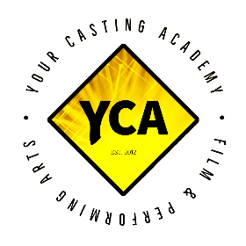
YOUR CASTING ACADEMY
YCA Screen Acting Program – Application Form

Please complete the application form below. The information is gathered to place you in the appropriate classes and to get a sense of your acting level/experience. Once you have submitted your application, we will review it and send you further information and an audition dates.

Application Date: Applying for Fall or Winter Term:
APPLICANT’S INFORMATION

Last Name: First Name:

Mailing Address:
Street/Apt# | City
Province | Postal Code

Age: Phone #: Email:

Alternative Phone #: Alternative Email:

Emergency Contact Name: Phone #

Agent Representation (if any):

Instagram Handle: Facebook Name/Account:

Twitter Handle: IMDB PAGE:

TRAINING PLAN & AVAILABILITY

Please check mark with an “x” which of our Part Time Acting Programs you are applying for,

Basic: | Advanced: | Expert: | Master: | Custom:

Please check mark with an “x” all the days you are available for training.

Mon 7pm-10pm

Tues 7pm-10pm

Wed 7pm-10pm

Thur 7pm-10pm

Sat 10am-8pm

Sun 10am-8pm

Are there any limitations regarding your availability not mentioned above: (please list all in box below – example: I have limited availability on weekends and am only available mornings):

PLEASE CHECK MARK BY TYPING “x” which best describes you (Check mark only one):
I am a beginner
I have taken acting courses before in the past 3 to 5 years
I have taken acting courses before in the past, over 5 years ago

PLEASE CHECK MARK which best describes you (Check mark only one):
I want to learn screen acting and become a f/t actor
I want to learn screen acting to make supplementary income
I’m just doing this for fun / as a pass time hobby

OTHER

Do you have any performance experience on stage or on screen?

Do you have any other certifications, awards or honorable mentions in any trade?

Why do you want to become an actor or learn the craft? And how far is your willingness to learn? Are you willing to commit to other training courses such as voice animation?

***Please add info@yourcasting.ca to your contact / safe list with your email account so as to avoid YCA’s important memos, notices, and other announcements going into your spam folder***

